Life Savers  
  
Not just another day at the beach

Contents

**Overview** 2

**Product Details** 2

*Players* 2

*Genre* 2

*Platform* 2

*Outlets* 2

**Summary** 2

**Pillars** 2

**Revision History**

|  |  |  |
| --- | --- | --- |
| **Version** | **Date** | **Details** |
| 0.1 | 23.04.2021 | Initial Document |
|  |  |  |
|  |  |  |
|  |  |  |
|  |  |  |
|  |  |  |
|  |  |  |

# Product Overview

## 

## **One Line Summary**

Saving lives on the beach of Bondi takes more than just stamina

## **Description**

*Life Savers* is a life management sim, whereby you manage the mental health and stamina of your life saving crew in Bondi Beach Life Savers Club

**Details**

* Players: Single Player
* Genre: Management style game / Isometric
* Platform: PC

## **Unique Selling Points**

* A closer look at the inner workings of the Lifesaving volunteers of Australia
* Beach culture aesthetics
* Diorama art style

## **Target Market**

While defining the target market, there are two approaches, one of aesthetics, representing Australia and its beach culture (using Bondi as a famous example) and the other of sim management.

* Casual players
* Players that enjoy a level of micro management
* Australians
* Beach goers

## **Design Pillars**

* Emotional, Physical and Mental Stress management
  + Focusing on the welfare of your life saving team and managing each unique character’s strengths and weakness to use them in the appropriate scenario
* State Management
  + Characters will adopt states which allow them to patrol and react to situations depending on their states (stressed, determined, energetic, etc…)

**Game Loop**

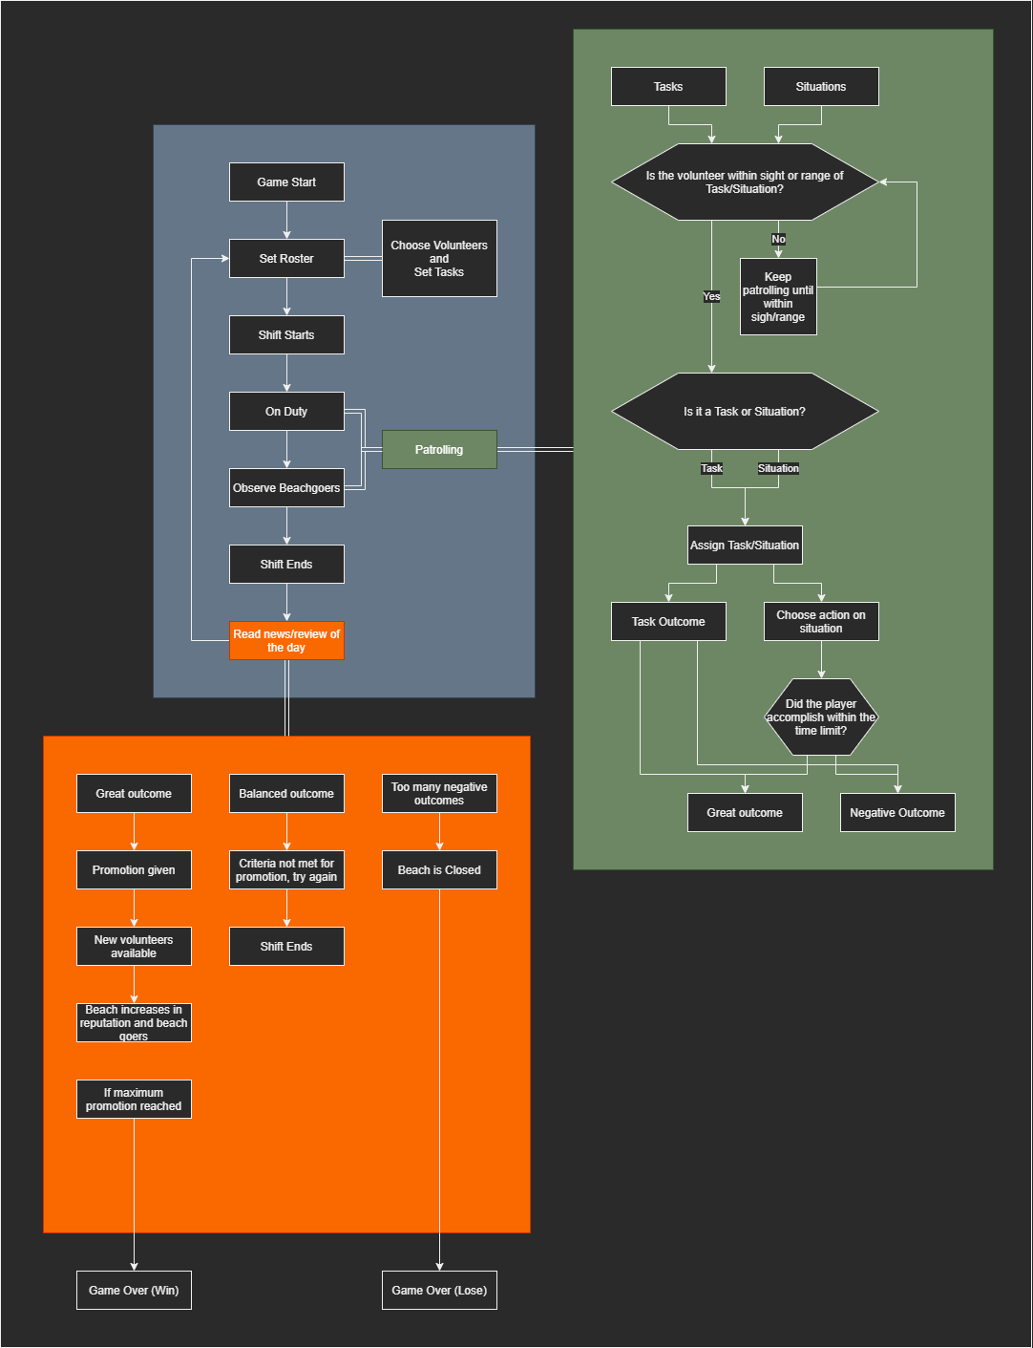

# **Mechanics and Systems**

* Movement & Camera
  + Scene transitions between areas (beach, roster, office, sea/ocean)
  + Movements are scripted to demonstrate outcomes of the states of the characters
* Notifications
  + Notifications occur if there are moment that players need to address, from stressed (breakdown moments) to situations happening at the oceans (drowning, tom foolery)
* Menu
  + Simple menu system that allows play, pause, sound control
* Roster
  + Players ability to assign and change the roster of the volunteers that work, whether they need a break and be replaced by someone fresh, or to assign a task to a well skilled volunteer
* State System
  + Idle, Patrolling, or performing a task, this will be dependant on the circumstances and events of the team members and will dictate their actions as a result
* Equipment usage system
  + Team members can use the available equipment (buggy, life saving board) to better manage their Stamina and mental health meters if available

# **Controls**

* PC
  + Mostly mouse controls to react to notifications and drag and drop volunteers into a proper position for the roster

# **Key Characters**

* Manager
  + The player, who manages the roster and assigns volunteers the tasks
* The Volunteers
  + 5 Volunteers to manage with their own personalities

**Player Progression**

* At the passing of each day/week, a report comes up with reviews of the volunteer’s morale.
* There are news of any incidents and reflect how positively or negatively dealt with depending on players choice

**Level Design**

Simple Environment of a shot of the beach, a shot of an office and an image of a roster

* Bondi Beach
  + The level is a shot of Bondi Beach in which the volunteers act and react to what happens there
* Office
  + The are in which the player can decide what to organise, from the roster to the equipment allocation and crew evaluation, review and reports to make an informed decision as to how the volunteers will work

**Themes and Story**

It is the first day of managing a volunteer life saver club at Bondi, the themes are beach, sunny days for the most part, patrons at risk of drowning, or curbing poor behaviour, like litter and graffiti etc

**The Story**

The story is the player is hired as a manager to manage the volunteer crew and maintain a good working environment that takes care of the welfare, physically and mentally of each of the unique members

**Art Style and Aesthetic**

* Colour Palette

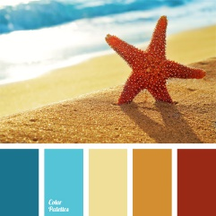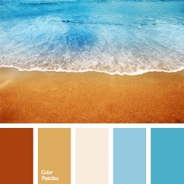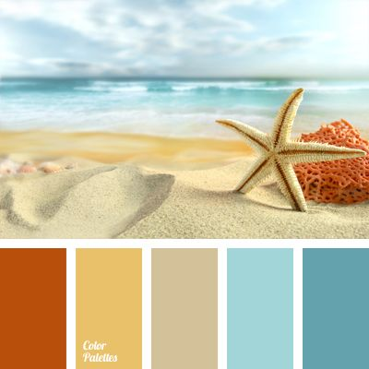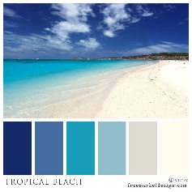

* Character Art Style

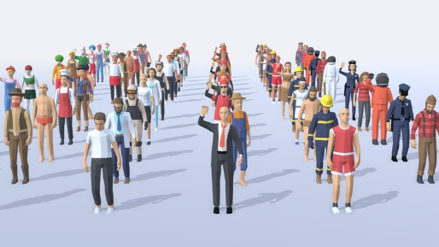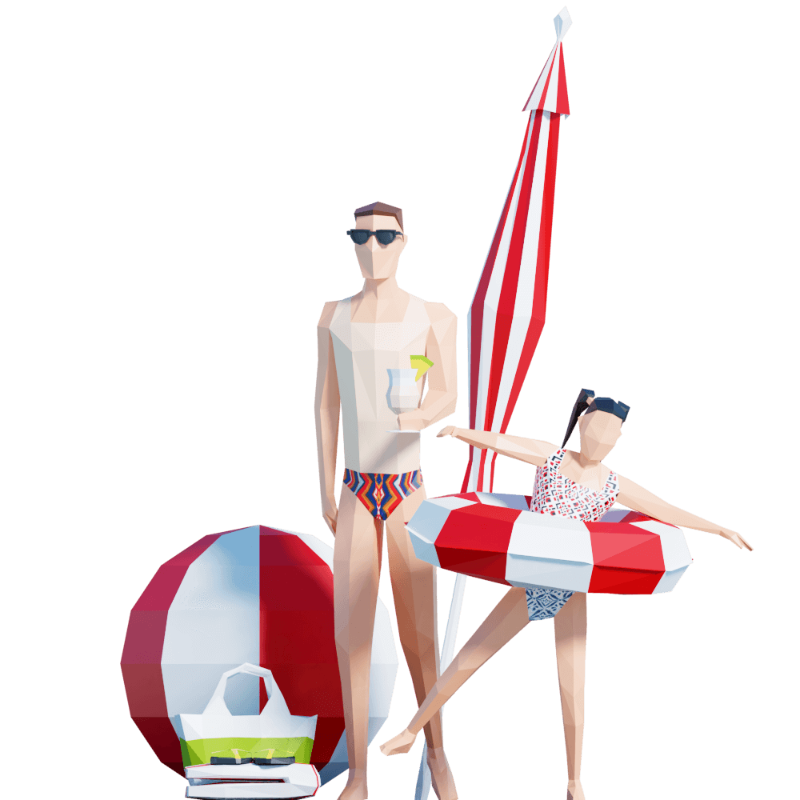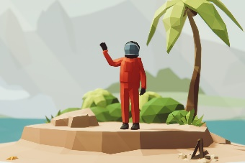

* Environmental Art Style

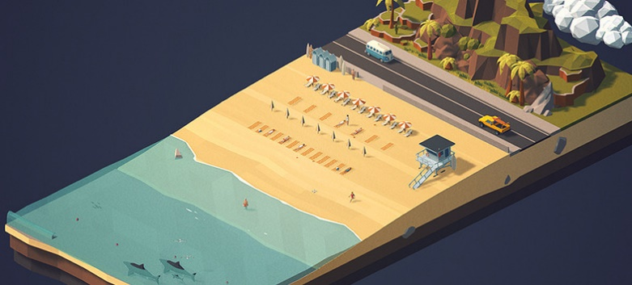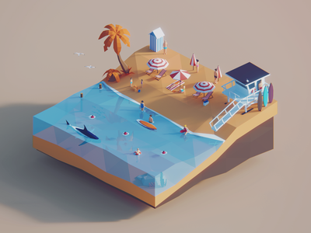

* Lighting

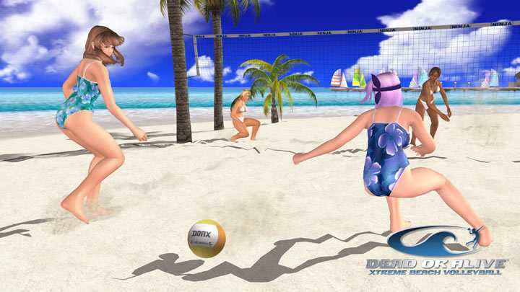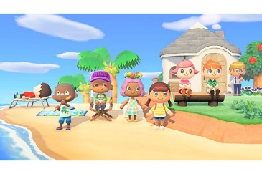

**Sound**

* Music (Music will change depending on the mode (Office/Beach) and circumstances (Chill no events / Hectic dramatic action))
  + Chiptunes style of music (Synthwave, Retro Chill)
    - Highway Superstar – Skylines
    - Slumber – Qwerty Woman
    - City Limits – Lakey Inspired
  + Chillout Lounge Style as an alternative
* SFX
  + Beach Waves
  + Crowd sound
  + Water
  + Running
  + Paper Rustling (Roster)
  + Click/Typing sounds (emulating using a computer to set tasks)
  + Crowd yells (when a shark is spotted or drowning)
  + Emergency Alarm